Sprint 3- Agility Design Document

April 20th, 2023

Table of Contents
1. Executive Summary 3
1.1 Project Overview 3
1.2 Purpose and Scope of this Specification 3
2. Product/Service Description 3
2.1 Product Context 3
2.2 User Characteristics 3
2.3 Assumptions 3
2.4 Constraints 3
2.5 Dependencies 4
3. Requirements 4
3.1 Functional Requirements 5
3.2 Security 5
3.2.1 Protection 5
3.2.2 Authorization and Authentication 6
3.3 Portability 6
4. Requirements Confirmation/Stakeholder sign-off 6
5. System Design 6
5.1 Algorithm 6
5.2 System Flow 6
5.3 Software 6
5.4 Hardware 6
5.5 Test Plan 7
5.6 Task List/Gantt Chart 7
5.7 Staffing Plan 7

Executive Summary

Project Overview
Sphereo is an introductory program intended to introduce the user to basic procedural programming and implementing code that results in physical action being taken. Being a basic robotics program, the project is intended to give a surface-level understanding of robotics and programming that will be built upon with subsequent lessons.

Purpose and Scope of this Specification
In scope
- Creation of an algorithm that successfully runs the designated course
- Clean code will be provided that can be expanded upon for the next triathalon events
Out of Scope
- Making a program that exceeds the limits of the Sphereo hardware, by exceeding its maximum speed, endurance, etc.

Product/Service Description

Product Context
This product will demonstrate how Bluetooth can be utilized with creative hardware to create a new learning experience. The interface with which to plan out the algorithm is hosted within a phone app, and communicates with the sphere robot remotely. This Sphereo project relies on several already existing systems in order to function.

User Characteristics

One person utilizing this data would be an introductory computer science student, whom would use this product as a jumping-off point for further research into how robotics is coded. Little technical expertise is needed to utilize Sphereo, and thus the barrier of entry is low for anyone looking to learn from the algorithm. Block code provides this user with easy to understand building blocks for a deeper understanding of designing an algorithm.

Another type of person utilizing this product would be an instructor, either utilizing it as an example to share with future classes, or a method of judging the developer’s progress within the class. Knowing much more about computer science, the algorithm could potentially help the instructor in future lectures by providing a personal, organic result of their teachings.

Assumptions
Iphones and laptops capable of running Sphereo software will be available at all times. Bluetooth connectivity between developing hardware and the sphere will be present at all times. The operating systems for which our iPhones and laptops run on will be intact and running whenever needed.

Constraints
- Mac and iphone can get full data, including the motion chart, while normal pcs cannot.
- Time restriction is until the 20th of april, 2023
- Triathalon algorithm must be easily shared between both developers, and agreed upon when finished.
- Framework must be concise before developing final algorithm.
- Speed must be implemented after a functional algorithm is developed

Dependencies
- Sphereo, as well as the operating system it runs on, must be updated to the latest versions.
- This product will require a download from Github
- The user must know how to translate the algorithm into the Sphereo progam.

Requirements

Functional Requirements
Req# | Requirement | Comments | Priority | Date Rvwd | SME Reviewed / Approved
Agility_01 | Roll through first part of course without hitting bottles | Approved. The first part of the course is steadily navigated | High | 4/5/23 | Approved
Agility_02 | Successfully jump off ramp, end at last vertex | Approved. Ball successfully makes It over ramp | High | 4/15/23 | Approved
Agility_03 | Run through pins at very end | Approved, successful pin hit | High | 4/15/23 | Approved
Agility_04 | Run through course in one fluid motion | Approved. Couse is successful in one take | High | 4/19/23 | Approved

Security

Computers containing Data required to use the robot will only be in personal devices (Victor and Jack’s Computers).

Protection

All data will be saved locally, and confined to two flash drives containing all of the data. A VPN will be used to ensure computer security is not breached.

Authorization and Authentication
Only Jack and Victor are authorized to work on this assignment. Authentication will involve solely working with each other on the project

Portability
Code will be posted to github, making it easily downloadable for anyone looking for an introduction to Sphereo.

Requirements Confirmation/Stakeholder sign-off
Meeting Date | Attendees (name and role) | Comments
4/5/23 | Victor and Jack | Collaboration on algorithm, as well as sharing of ideas for development. Confirmed basic ideas
4/15/23 | Victor and Jack | Algorithm confirmed, testing in next few days
4/19/23 | Victor and Jack | Video taken, successful application of algorithm
4/19/23 | Victor and Jack | Final project uploaded

System Design

Algorithm
- Start Program
- roll 0 degrees at 42 speed for 2.3 seconds
- Stop
- roll 90 degrees at 42 speed for 2.4 seconds
- Stop
- roll 0 degrees at 45 speed for 2.3 seconds
- Stop
- Delay for .2 seconds
- roll 90 degrees at 170 speed for 1.5 seconds
- Stop
- Delay for 1 second
- roll 225 degrees at 89 speed for 7 seconds
- End program

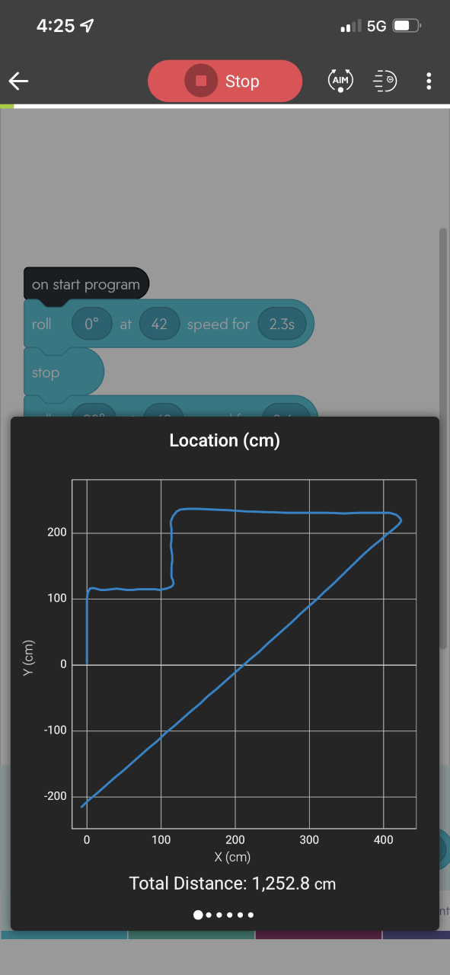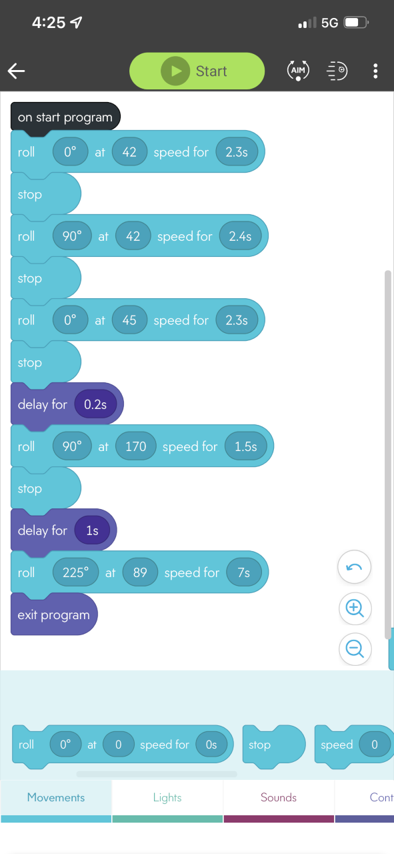

System Flow
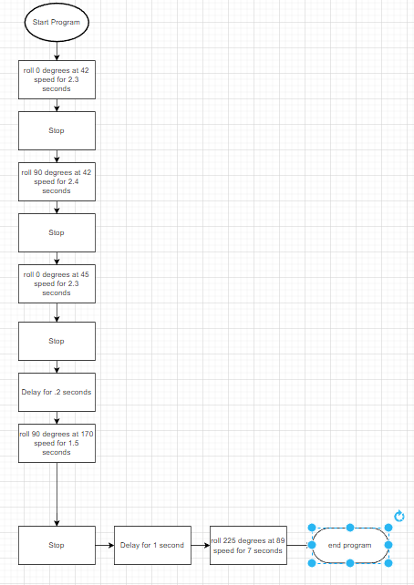

Software
Sphereo’s programming relies on javascript, and is hosted on the Sphereo app. Flowcharting and designing of the program will be done using draw.io

Hardware
A Mac computer, as well as an iPhone 12 will be used to develop, test, and apply the algorithm for the entirety of the project.

Test Plan
Include a test plan showing all unit tests performed for this application, Include test rational, test date, staff member, pass/fail status

Reason for Test Case | Test Date |  | Expected Output |  | Observed Output |  |  | Staff Name | Pass/Fail
To confirm that original algorithm passed the obstacle course | 04/15/2023 |  | Successful Completion of the obstacle course |  | The ball turned too early, resulting in the ball hit the first bottle |  | Victor and Jack |  |  | Fail
To check changed algorithm and to see if it passes the obstacle course | 04/15/2023 |  | Successful Completion of the obstacle course |  | The Ball turned too early on the second turn, resulting the ball to hit the third bottle |  | Victor and Jack |  |  | Fail
To check changed algorithm and to see if it passes the obstacle course | 04/15/2023 |  | Successful Completion of the obstacle course |  | Ball was moving too slow to successfully jump the ramp |  | Victor and Jack |  |  | Fail
To check changed algorithm and to see if it passes the obstacle course | 04/15/2023 |  | Successful Completion of the obstacle course |  | Ball continued to roll instead of stopping at the correct place to accurately line for the markers |  | Victor and Jack |  |  | Fail
To check changed algorithm and to see if it passes the obstacle course | 04/15/2023 |  | Successful Completion of the obstacle course |  | Successful Completion of the obstacle course |  | Victor and Jack |  |  | Pass
To confirm correct operation of algorithm |  | 04/19/2023 |  | Successful Completion of the obstacle course |  | Successful Completion of the obstacle course | Victor and Pass  Jack

Task List/Gantt Chart

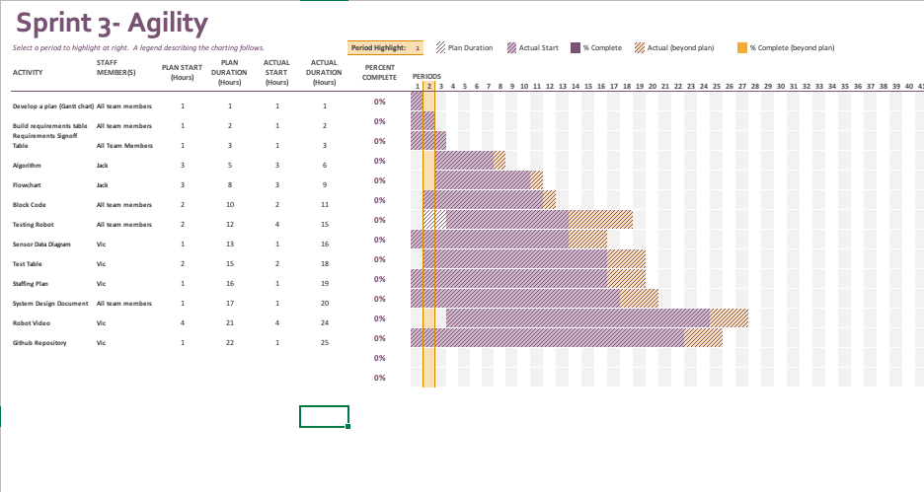

Staffing Plan

Name | Role | Responsibility | Reports To
Jack Miller | Lead Developer | Develop algorithm for Sphereo | Victor
Victor Davidson | Project Manager | Ensure deadlines are met, communications are frequent | Jack

